1.What do you mean by AutoComplete feature in Excel and what are the

benefits of using this feature?

AutoComplete **helps you quickly insert functions and arguments while minimizing typing and syntax errors**. The AutoComplete menu shows you available options based on context, and you choose what you want to insert into your formula.

2. Explain working with workbooks and working with cells.

A workbook is a spreadsheet program file that you create in Excel. A workbook contains one or more worksheets. A worksheet (also known as a spreadsheet) consists of cells in which you can enter and calculate data. The cells are organized into columns and rows. A worksheet is always stored in a workbook. A workbook can contain many worksheets. Think of it as a book. The book (workbook) usually has a single topic, such as your budget. Each page (worksheet) within the book contains part of that topic, such as the budget broken down into months. Tabs at the bottom of the window allow you to flip between worksheets in a workbook or insert a new worksheet in a workbook.

3. What is fill handle in Excel and why do we use it?

Suppose you have the data as shown below:

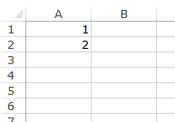

Here are the steps to use the fill handle to quickly insert numbers up to 20.

* Select the data set.
* Hover the mouse over the bottom-right edge of the selection, you would see a plus icon appear – How to Use Fill Handle in Excel - Plus Icon Small
* Click the left button on the mouse and drag it down. Excel identifies a pattern of the first 2 numbers (an increment of 1) and uses that to fill that entire series.

If you have data in the adjacent column, you can also hover the mouse over the right edge of the selection and double click. It will automatically fill the list to the last cell based on the data in the adjacent column.

For example, if I double-click on the fill handle (as shown below), it will fill the column till cell A11 (since there is data until cell B11 in the adjacent column.



4. Give some examples of using the fill handle.

f you have data in the adjacent column, you can also hover the mouse over the right edge of the selection and double click. It will automatically fill the list to the last cell based on the data in the adjacent column.

For example, if I double-click on the fill handle (as shown below), it will fill the column till cell A11 (since there is data until cell B11 in the adjacent column.



**Examples of Using Fill Handle in Excel**

In the above examples, we saw how to use fill handle in excel to complete the list of numbers (that increment by 1).

There are many more situations when a fill handle can automatically detect the pattern and fill the cells.

Here are the inbuilt fill handle patterns you can use:

**Autofill Numbers that Increment/Decrement by 1**

As shown above, you can quickly fill cells when the number increments/decrements by 1.



Note that the fill handle works in both directions. You can either fill down by dragging it down or fill up the dragging it upwards.

**Autofill Weekday Names**

You can use fill handle in Excel to autocomplete weekday names. It could either be the three alphabets nomenclature (Mon, Tue…) or the full name (Monday, Tuesday…).



5. Describe flash fill and what the different ways to access the flash fill are.

* Enter the full name in cell C2, and press **ENTER**.
* Start typing the next full name in cell C3. Excel will sense the pattern you provide, and show you a preview of the rest of the column filled in with your combined text.
* To accept the preview, press **ENTER**.



If Flash Fill doesn't generate the preview, it might not be turned on. You can go to **Data** > **Flash Fill** to run it manually, or press Ctrl+E. To turn Flash Fill on, go to **Tools** > **Options** > **Advanced** >**Editing Options** > check the **Automatically Flash Fill** box.

6. Extract first name and last name from the mail id and then from the

address column, extract the city, state, and pin code using the flash fill.

Given below is an example of the columns you have to create. Paste the

screenshot of what you have created using the flash fill command.

Extract text from cell (split columns)

Before Flash Fill came into existence, splitting the contents of one cell into several cells required the use of the [Text to Columns](https://www.ablebits.com/office-addins-blog/split-text-string-excel/) feature or [Excel Text functions](https://www.ablebits.com/office-addins-blog/excel-substring-functions-extract-text/). With Flash Fill, you can get the results instantly without intricate text manipulations.

Supposing you have a column of addresses and you want to extract zip codes into a separate column. Indicate your goal by typing the zip code in the first cell. As soon as Excel understands what you are trying to do, it fills in all the rows below the example with the extracted zip codes. You only need to hit Enter to accept them all.  
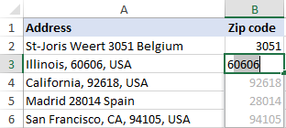

*Formulas to split cells and extract text:*

* Extract substring - formulas to extract text of a specific length or get a substring before or after a given character.
* Extract number from string - formulas to extract numbers from alphanumeric strings.
* Split names in Excel - formulas to extract first, last and middle names.

*Extracting and splitting tools:*

* Text Toolkit for Excel - 25 tools to perform various text manipulations including splitting a cell by any character such as comma, space, line break; extracting text and numbers.
* Split Names tool - fast and easy way to separate names in Excel.

Combine data from several cells (merge columns)

If you have an opposite task to perform, no problem, Flash Fill can concatenate cells too. Moreover, it can separate the combined values with a space, comma, semicolon or any other character - you just need to show Excel the required punctuation in the first cell:  
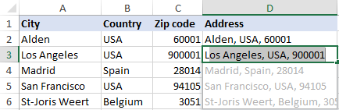

This method is especially useful for combining various name parts into a single cell as shown in

*Formulas to join cell values:*

* CONCATENATE function in Excel - formulas to combine text strings, cells and columns.

*Merging tools:*

* Merge Tables Wizard - quick way to combine two tables by common columns.
* Merge Duplicates Wizard - Combine similar rows into one by key columns.

Clean data

If some data entries in your worksheet begin with a leading space, Flash Fill can get rid of them in a blink. Type the first value without a preceding space, and all extra spaces in other cells are gone too:  
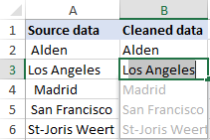

*Formulas to clean data:*

* Excel TRIM function - formulas to remove excess spaces in Excel.

*Data cleaning tools:*

* Text Toolkit for Excel - trim all leading, trailing and in-between spaces but a single space character between words.

Format text, numbers and dates

Quite often the data in your spreadsheets is formatted in one way while you want it in another. Just start typing the values exactly as you want them to appear, and Flash Fill will do the rest.

Perhaps you have a column of first and last names in lowercase. You wish the last and first names to be in proper case, separated with a comma. A piece of cake for Flash Fill :)  
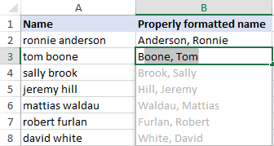

Maybe you are working with a column of numbers that need to be formatted as phone numbers. The task can be accomplished by using a predefined [Special format](https://www.ablebits.com/office-addins-blog/excel-format-number-text/#Special-format) or creating a [custom number format](https://www.ablebits.com/office-addins-blog/custom-excel-number-format/). Or you can do it an easy way with Flash Fill:  
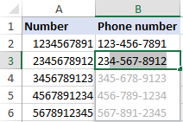

To re-format the dates to your liking, you can apply the corresponding [Date format](https://www.ablebits.com/office-addins-blog/change-date-format-excel/#change-date-format) or type a properly formatted date into the first cell. Oops, no suggestions have appeared… What if we press the Flash Fill shortcut (Ctrl + E) or click its button on the ribbon? Yep, it works beautifully!  
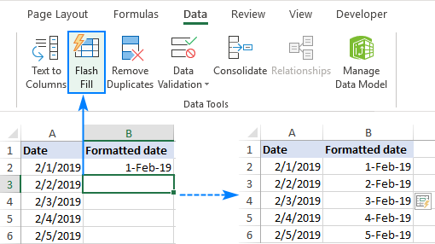

Replace part of cell contents

Replacing part of a string with some other text is a very common operation in Excel, which Flash Fill can also automate.

Let's say, you have a column of social security numbers and you want to censor this sensitive information by replacing the last 4 digits with XXXX.

To have it done, either use the [REPLACE](https://www.ablebits.com/office-addins-blog/excel-replace-substitute-functions/#Excel-REPLACE-function) function or type the desired value in the first cell and let Flash Fill auto fill the remaining cells:  
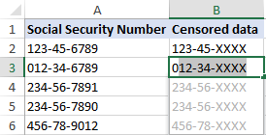

Advanced combinations

Flash Fill in Excel can accomplish not only straightforward tasks like demonstrated in the above examples but also perform more sophisticated data re-arrangements.

As an example, let's combine different pieces of information from 3 columns and add a few custom characters to the result.

Supposing, you have first names in column A, last names in column B, and domain names in column C. Based on this information, you want to generate email addresses in this format: *initial.surname@domain.com*.

For experienced Excel users, there is no problem to extract the initial with the [LEFT](https://www.ablebits.com/office-addins-blog/excel-left-function/) function, convert all the characters to lowercase with the LOWER function and concatenate all the pieces by using the [concatenation operator](https://www.ablebits.com/office-addins-blog/excel-concatenate-strings-cells-columns/#concatenation-operator):

**=LOWER(LEFT(B2,1))&"."&LOWER(A2)&"@"&LOWER(C2)&".com"**  
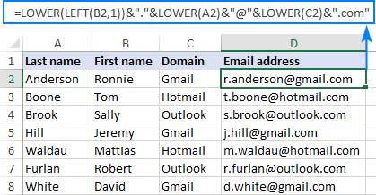

But can Excel Flash Fill create these email addresses for us automatically? Sure thing!  
